# Program 1

//a program to depict the function overloading concept

#include<iostream>

using namespace std;

float area(float r)

{

return (3.141)*r*r;

}

int area(int a,int b)

{

return a*b;

}

int area(int s)

{

return s*s;

}

int main()

{

float r,ac;

int a,b,s,ar,as;

cout<<"\nenter the radius of circle : ";

cin>>r;

ac=area(r);

cout<<"\nenter the length and breadth of rectangle : ";

cin>>a>>b;

ar=area(a,b);

cout<<"\nenter the side of the square : ";

cin>>s;

as=area(s);

cout<<"\narea of the circle is : "<<ac;

cout<<"\narea of the rectangle is : "<<ar;

cout<<"\narea of the sqaure is : "<<as;

return 0;

}

Output:-

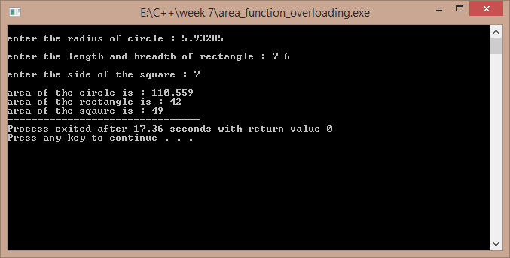

# Program 2

//a program to add complex numbers using operator overloading

#include<iostream>

using namespace std;

class complex1

{

float real,imag;

public:

complex1()

{

real=imag=0;

}

complex1(float a,float b)

{

real=a;

imag=b;

}

void display();

complex1 operator +(complex1 m);

};

void complex1::display()

{

cout<<"\n"<<real<<" + "<<imag<<"i"<<endl;

}

complex1 complex1::operator +(complex1 m)

{

complex1 temp;

temp.real=this->real+m.real;

temp.imag=this->imag+m.imag;

return temp;

}

int main()

{

complex1 a,b;

float p,q,r,s;

cout<<"\nenter the real and imaginery part of first complex number : ";

cin>>p>>q;

cout<<"\nenter the real and imaginery part of second complex number : ";

cin>>r>>s;

a=complex1(p,q);

b=complex1(r,s);

complex1 c;

c=a+b;

cout<<"\nthe addition complex number is : ";

c.display();

return 0;

}

Output:-

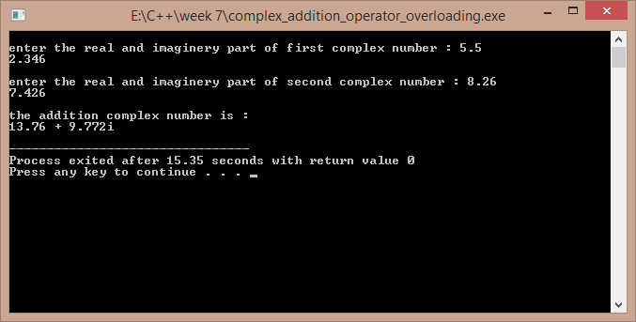

# Program 3

//a program to overload the operator regarding the strings

#include<iostream>

#include<cstring>

using namespace std;

class str

{

char *s;

int l;

public:

str()

{

l=0;

s=new char[l+1];

}

str(char *p)

{

l=strlen(p);

s=new char[l+1];

strcpy(s,p);

}

str(int k)

{

l=k;

s=new char[l+1];

}

str operator +(str);

int operator <(str);

int operator >(str);

void operator =(str);

int operator !=(str);

void display()

{

// cout<<this->l;

cout<<"\n"<<this->s;

}

};

str str::operator +(str a)

{

str t;

t=str(strlen(this->s)+strlen(a.s));

strcpy(t.s,this->s);

strcat(t.s,a.s);

return t;

}

int str::operator >(str a)

{

if(strcmp(this->s,a.s)>0)

return 1;

else

return 0;

}

int str::operator <(str a)

{

if(strcmp(this->s,a.s)<0)

return 1;

else

return 0;

}

void str::operator =(str a)

{

strcpy(this->s,a.s);

}

int str::operator !=(str a)

{

if(strcmp(this->s,a.s)!=0)

return 1;

else

return 0;

}

int main()

{

str x,y;

char temp[100];

cout<<"\nenter the first word : ";

cin>>temp;

x=str(temp);

cout<<"\nenter the second word : ";

cin>>temp;

y=str(temp);

str xy;

xy=x+y;

cout<<"\nthe joint of the words is : ";

xy.display();

cout<<"\nhere x is the first word and y is the second word .";

cout<<"\nthe result of x>y is : "<<(x>y);

cout<<"\nthe result of x<y is : "<<(x<y);

cout<<"\nthe result of x!=y is : "<<(x!=y);

return 1;

}

Output :-

